Clinical Research Center
Brain Research, Innovation & Translation Labs
2230 Liliha Street #104
Honolulu, Hawaii 96817, USA
Dedicated Research Lines: (808) 564-6141, Fax (808) 443-0774

Neuroscience Research
Center for Neuroscience Diversity

Our Commitment to
Neuroscience Diversity, Equity & Inclusions

2021-2022
Reports & Statistics

Neuroscience Clinical Trials 41 (3 NIH funded)
Neuroscience Research Projects: 21
PubMed Full Length Articles Published: 8
National or International Poster Presentations: 17
Table of Contents
NIH NIMHD call to action……………………………………………….………………….…….…………3

FDA Guide to “Diversity Plans to Improve Enrollment of Participants from
Underrepresented Racial and Ethnic Populations in Clinical Trials Guide for Industry…….….……………3

Clinical Research Center - Facilities & Capabilities………...……………………………………………….4

Brain Research, Innovation & Translation Laboratory, Research Faculty……………………...……………5

Stroke and Neurovascular Diseases Research Lab………………………………………….………………..6
Stroke and Neurologic Restoration Center

Lifestyle Research Lab………………………………………………………………………………………7
Self-Care, Lifestyle and Wellness Center

Brain Mapping Research Lab………………………………………………….……………………………..8
Video-EEG Epilepsy Monitoring Unit, Neurodiagnostic Laboratory

Neuro COVID Research Laboratory (NIH/NYU Funded)………………………………….………..……...9-10
NeuroCOVID Clinic

Neuromuscular Research Unit………………………………………………………………………………..11
Neuromuscular Rehabilitation Center

TBI Research Lab……………………………………………………………….……………………………12
TBI Center

Sleep Research Lab……………………………………………………………….…………………………..13
Sleep and Insomnia Center

Parkinson’s and Neurodegenerative Disease Research Lab…………………………………….……………14
Parkinson’s & Movement Disorders Center

Alzheimer’s Research Unit……………………………………………………….…………..………………15
Memory Disorders Center

Headache Research Unit………………………………………………………….…………….…………….16
Headache and Facial Pain Center

Pain Research Unit……………………………………………….………………..…………………….……17
Spine and Pain Management Center

MS & Neuroimmunology Research Lab………………………………………….…………………………..18
Comprehensive MS Center

Epilepsy Research Unit……………………………………………………………………………………….19
Comprehensive Epilepsy Center

Neuromodulation & Brain Computer Interface Laboratory………………………………………………….20
Center for Neuromodulation

Publications Student or Resident led Publications………………………………………………...………21
Neuroscience Faculty Publications…………………………………………………………..25
According to NIH NIMHD (National Institute on Minority Health & Health Disparities), one of America’s greatest challenges is reducing the profound disparity in health status of its racial and ethnic minority, rural, low-income, and other underserved populations.

In 2022 April, FDA released “Diversity Plans to Improve Enrollment of Participants from Underrepresented Racial and Ethnic Populations in Clinical Trials Guidance for Industry” guidance “to provide recommendations to sponsors developing medical products on the approach for developing a Race and Ethnicity Diversity Plan (henceforth referred to as the “Plan”) to enroll representative numbers of participants from underrepresented racial and ethnic populations in the United States, such as Black or African American, Hispanic/Latino, Indigenous and Native American, Asian, Native Hawaiian and other Pacific Islanders, and other persons of color in clinical trials. Individuals from these populations are frequently underrepresented in biomedical research despite having a disproportionate disease burden for certain diseases relative to their proportional representation in the general population. Adequate representation of these populations in clinical trials and studies supporting regulatory submissions helps ensure that the data generated in the development program reflect the racial and ethnic diversity of the population expected to use the medical product if approved and may potentially identify effects on safety or efficacy outcomes that may be associated with or occur more frequently within these populations.”

According to 2020 US census Bureau, Asian is the 2nd fastest growing minority after Hispanics and yet, it is one of the most under-represented groups in any US clinical trials. We believe Hawaii can play an important role in reducing the disparity in minority participation & engagement in clinical trials or research especially for minority groups as defined by NIH National Institute on Minority Health & Health Disparities (NIMHD)

- Asian Americans (7% of US & over 40% of Hawaii’s population)
- Native Hawaiians and Pacific islanders (10% of Hawaii’s population)
- Underserved rural population (94% Hawaii’s landmass)

Hawaii is one of the most diverse US states and one of 6 states with majority minority population and home to several NIMHD designated US health disparity populations. Our team focus on promoting and collecting data on Hawaii’s diverse population to enhance scientific knowledge and designing interventions to improve health outcomes by improving health care access, reduce health disparities especially for minorities like Asians, Native Hawaiians and other Pacific islanders and underserved and underrepresented groups.

Hawaii Pacific Neuroscience (HPN) robust clinical and academic clinical and translational research programs is on the forefront of working with NIH & biomedical organizations to fosters a culture of innovation and collaboration and is recognized nationally for our work in neuroscience research. Whether our physicians investigators & partners are in the lab exploring science to understand a disease process, working in the clinic with patients on a clinical trial, collaborating with our global partners on trial conception, design and IND application, our focus, commitment, and our hearts will always be to our serve our patients and their precious ohana (families) and to improve their quality of life

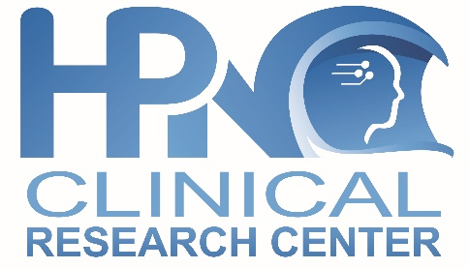
The Hawaii Center for Neuroscience Diversity working collaboratively with the Clinical Research Center (CRC) is fully staffed with full time investigators and credentialed, experienced and qualified research raters and staff.
The CRC is a highly sought after site and have a national reputation for successful completion and recruitment including rapid site start up. The CRC has successfully completed over 100 clinical trials and actively involved in investigations of:
- NIH NINDS Funded Hawaii site for NeuroCOVID Databank/Biobank
- Alzheimer’s, MCI, Preclinical and other related neurodegenerative disorders
- Parkinson’s, & other movement disorders including Huntington’s chorea, tremors
- Epilepsy, Seizures including acute abortive therapies in overnight EMU
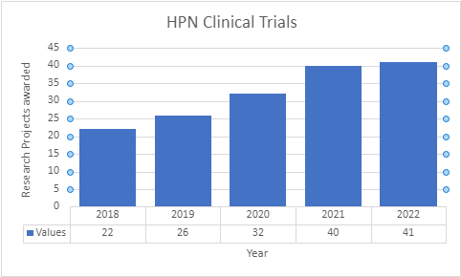
- MS, Neuroimmunology, Vaccine research
- Pain, Headache, Migraines research
- Neuromuscular including myasthenia gravis
- Concussion, traumatic brain injury
- Narcolepsy and other sleep disorders
- Stroke and Neurovascular research
- Neurodevice, neuromodulation studies
- Rare Neurological Diseases

Few recent examples of successfully investigated, FDA approved and launched products include Cenobamate for Epilepsy, Inbrija for Parkinson’s, Kesimpta for MS, Daridorexant for Insomnia in recent years.
See list of active recruiting clinical trials.

Fully Equipped & Experienced Phase 0, I, II, III and IV Trial Capable

The Neuroscience Center with its Centers of Excellence for disease specific disorders are fully integrated so that patients have easy access to the benefits of world class groundbreaking clinical research at the Clinical Research Center specially equipped with:

- Biomarker (CSF, serum, genetic) sampling,
- Phase 0 & Phase I Normal Volunteer and Patient Subject Studies
- PK studies in overnight PK Unit
- IV Infusion studies in IV Infusion Center
- 20 Exam rooms with dedicated Monitor rooms
- Central IRB for Rapid Site Start Up
- On-site 3T MRI
- On-site Radiology Department
- Onsite Spinal Tap/Fluoroscopic LP
- Onsite Pharmacy
- Onsite IV Infusion Center
- Onsite Emergency resuscitation equipment
- Central Laboratories use & experience
- Accredited Local Laboratory
- Refrigerated, ambient temperature centrifuge
- Refrigerators -20C freezer, -70 Freezer
- Onsite ABRET accredited & CliniLab certified EEG & VEEG Labs
- Onsite AASM Accredited & CliniLab certified Sleep Laboratory
- IATA certified Lab
- Ongoing GCP training
- Onsite EMG, EEG
- Locked/secure Drug storage temperature controlled and monitored daily

Brain Research, Innovation & Translation Laboratory (BRITL)
2022 Student Cohort, Abstracts & Poster Presentations
The Neuroscience Center for Diversity Advancement works closely with BRITL which foster collaboration, bench to bedside translation and a culture of innovation and collaboration between departments, centers, institutions, and outside organizations.

Physicians and scientists of diverse backgrounds work closely within and across centers, institutes, and schools to collaborate whether they are basic laboratory-based scientists, bio statisticians or clinicians to encourage cross disciplinary translation bench to bedside research. Our diverse faculty also mentor aspiring diverse residents, medical students & select graduate and undergraduate students under the “Brain Research, Innovation and Translation Lab (BRITL) Neuroscience Scholar Program” and the Hawaii Neuroscience Summer Internship Program (SIP).

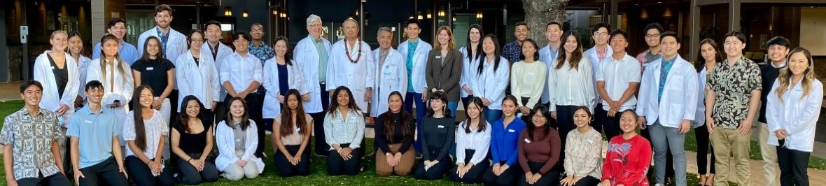
2022 BRITL Neuroscience Research Faculty & Mentors
Kore Liow, MD Neurology, Clinical Professor of Med (Neurology)
Jason Viereck, MD, PhD Neurology, Clinical Assistant Professor of Med (Neurology)
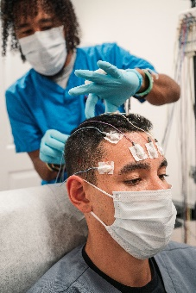
Enrique Carrazana, MD Neurology, Clinical Educator, Dept. of Med (Neurology)
Vimala Vajjala, MD Neurology, Clinical Assistant Professor of Med (Neurology)
Michael Slattery, MD Neurology, Clinical Assistant Professor of Med (Neurology)
Eliza Hagen, MD Neurology
Todd Uchima, PA-C Neurology
Chris Larrinaga, APRN Neurology
L. Nicole Little, PA-C, PhD Neurology
Jason Chang, MD Neurorehabilitation, Clinical Assistant Professor of Med
Kent Yamamoto, MD Neurorehabilitation, Clinical Assistant Professor of Med
David Baskin, MD Neurosurgery, Professor and Residency Program Director, Houston Methodist
Ricardo Burgos, MD Neuroradiology
Qing Li, PhD Neuroscience, Molecular Biosciences & Bioengineering, Professor, UH Manoa
Paul Smith, MD Brain Health, Lifestyle Medicine & Wellness, Clinical Assistant Professor
Sriharsha Vajjala, MD Sleep Medicine, Clinical Educator, Dept. of Med (Neurology)
Lawrence Burgess, MD Surgery, Professor of Surgery & Director of Student Affairs, SOM
John Chen, PhD Biostatistics, Professor & Chair, Dept. Quantitative Health

Chathura Siriwardhana, PhD Biostatistics, Assistant Professor, Dept. Quantitative Health

Stroke and Neurovascular Diseases Research Lab
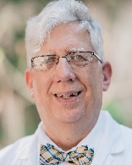
Lead Investigator: Jason Viereck, MD, PhD,
Neurologist & Director,
Stroke & Neurologic Restoration Center,
Clinical Assistant Professor of Medicine (Neurology)

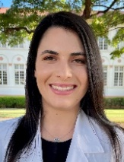
Investigating Prevalence of Carotid Artery Disease in Native Hawaiians and other Pacific Islanders Research Assistants/Medical Students: Julia Jahansooz
Ethnicity has previously been identified as a risk factor for ischemic stroke. Native Hawaiians and other Pacific Islanders (NHOPI) were on average 11 years younger at the onset of stroke than their Caucasian and Asian counterparts. The impact of ethnicity on prevalence of carotid artery disease, a precursor to stroke, in NHOPI has not previously been documented in Hawaii. This ethnographic study aims to quantify the prevalence and extent of carotid artery disease in Hawaii to better understand the pathogenesis of carotid artery atherosclerosis in different populations.

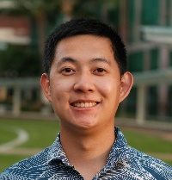
Investigating Carotid Artery Disease in Critically Understudied Populations: Comorbidities Seen in Native Hawaiians and Pacific Islanders Research Assistants/Medical Students: Anson Lee
Stroke is one of the primary causes of mortality and disability in the United States, and approximately 15% to 20% of all strokes are caused by carotid artery disease (CAD). Past surveys found evidence that among Native Hawaiian and Pacific Islander (NHPI) populations, individuals were four times more likely to suffer from a stroke and 30% more likely to die from a stroke compared to non-Hispanic white adults. Comorbidities associated with CAD are especially important to assess as multimorbidity was found to be common in stroke with 94% of stroke victims having at least one other long-term condition and 10% suffering from seven or more. Yet, clear-cut information and statistics about NHPI CAD risks, outcomes, and comorbidities have been difficult to ascertain. Our project investigates the types and number of comorbidities associated with CAD and its risk factors in NHPI patients compared to other ethnicities.
Investigating Young Atypical Stroke Risk Factors, Etiologies in Native Hawaiian and Pacific Islander Population Followed up at Hawaii Stroke & Neurologic Restoration Center Research Assistants/Medical Students: Michelle Lu,
Strokes in younger patients (<45 years) are relatively uncommon, making up 10-15% of stroke diagnoses. However, the risk of death in younger patients is higher, can disable individuals before their most productive economic years and lower their quality of life disproportionately. Studies have not only shown that stroke risk in Native Hawaiian/Pacific Islander (NHPI) populations is 30% higher than in non-Hispanic whites, but also show that NHPI patients hospitalized for ischemic stroke were also less likely to be older and more likely to be female when compared to whites. Compared to Asians, NHPI are also less likely to be older at the time of hospitalization. This study will aim to characterize the atypical stroke patients treated at Hawaii Stroke & Neurologic Restoration Center, investigating the presence of risk factors such as the use of oral contraceptives, smoking, hypertension, diabetes mellitus, dyslipidemia, obesity, vascular risk factors, congenital cardiac disease, as well as presenting symptoms such as hemiparesis, altered mental status, abnormal movements, migraine with aura. We would also like to identify atypical causes, such as hypercoagulable states, medication-induced thrombosis, vascular conditions, drug abuse, and cardiac malformations that might have led to stroke in younger patients.
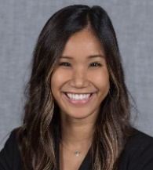
Evaluating the Role of Socioeconomic Status in Post-Stroke Disability Outcomes in Patients Cared for at Hawaii Stroke & Neurologic Restoration Center
Research Assistants/Medical Students: Amanda Chau
Hawaii’s multicultural community has not been thoroughly studied, despite its significantly higher prevalence of stroke. Socioeconomic status has been shown to be a factor in post-stroke outcomes. This project will investigate the effect of socioeconomic status (SES), race, and ethnicity on post-stroke disability outcomes in Hawaii. Identifying populations in Hawaii that may be at risk for worser post-stroke disability outcomes may lead to better post-stroke care amongst these groups.
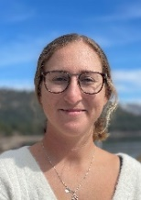
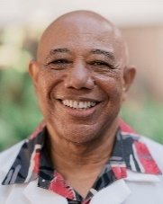
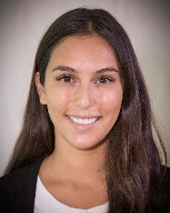
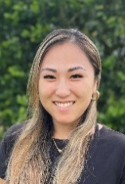
Lifestyle Research Unit
Lead Investigator, Paul Smith, MD,
Director, Self-Care, Lifestyle & Wellness Center
Clinical Assistant Professor of Medicine

Utilization of a Risk Acuity Scorecard for Comparison of Stroke Pre and Post Therapeutic Lifestyle Intervention Efficacy? Research Assistants/Medical Students: Vanessa Rubel, Hannah Bulosan, Stephanie Matsuura,
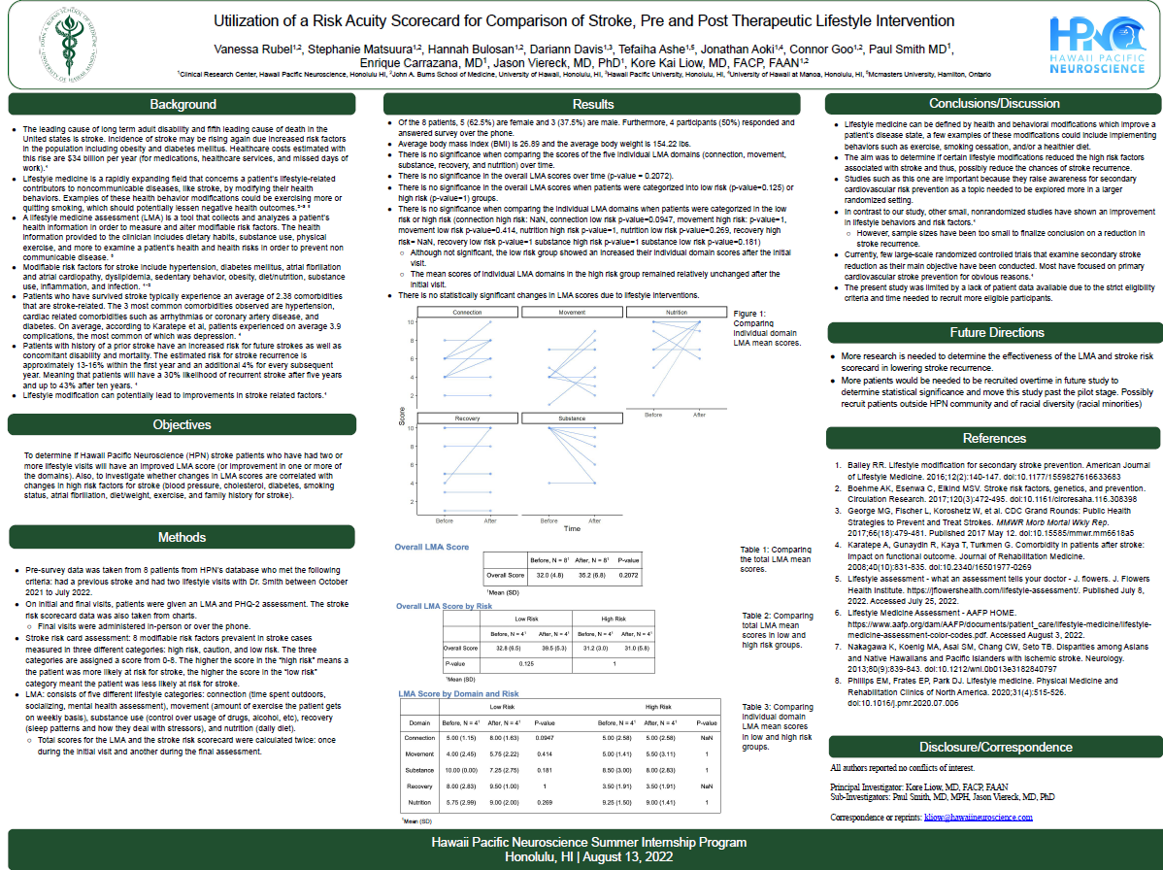
Lifestyle interventions are a way to prevent, treat, and reverse diseases. The risk factors for stroke (i.e. obesity, hypertension, diabetes, smoking, etc.) are addressed by behavioral changes implemented by an individual undergoing therapeutic lifestyle intervention. By introduction of the Lifestyle Medicine Assessment (LMA) tool at the initial entry of a stroke patient into therapeutic lifestyle intervention we are able to capture subjective information and quantify that data into five objectively measurable domains- connectedness, movement, nutrition, recovery, and substance use. Our study will determine if a six month therapeutic lifestyle intervention produces any significant changes within deficient domains and across all five domains as reflected in the Lifestyle Score Total. These scores will also be assessed by grouping of patients based on their initial risk acuity scorecard categorization of: low, moderate, or high risk.
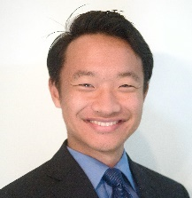
Brain Mapping Research Laboratory
Lead Investigator, Vimala Vajjala, MD, Neurologist & Director, EEG, Video-EEG & Clinical Neurophysiology Lab, Clinical Educator of Medicine (Neurology)

Can EEG Patterns Predict Onset of Preclinical Alzheimer’s Disease?
Research Assistants: Medical Students Enze Ma, Charissa Tan, Nathan Kim
HPN BRITL Brain mapping research lab. is dedicated to studying how neuronal cortical networks interact with the external environment through neurophysiologic and neuroimaging modalities. The integration of behavioral neuroscience, neurophysiology and bio signal processing knowledge is translated into developing better understanding of cortical physiology and how to improve quality of life of those suffering from neurological disorders
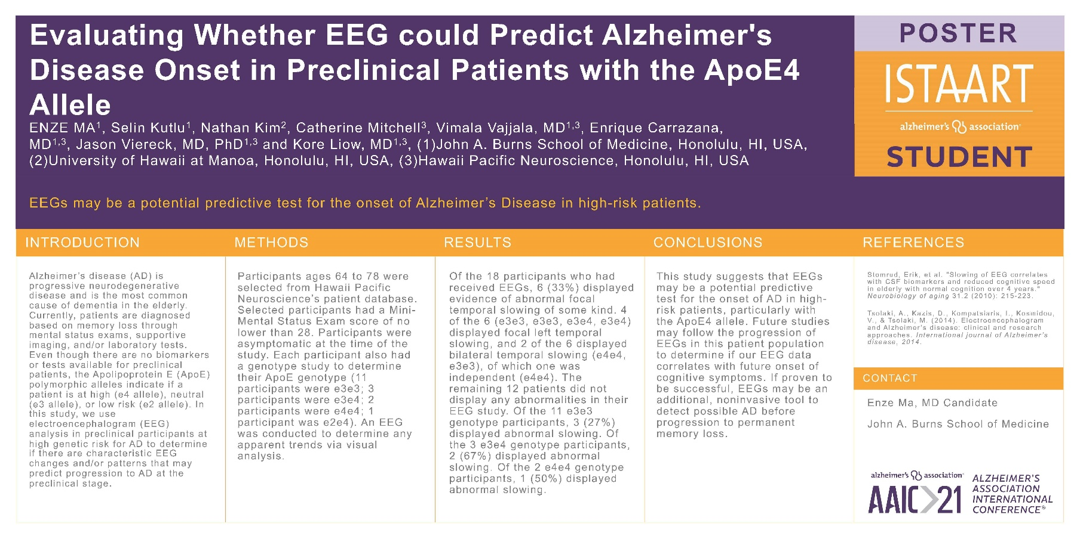

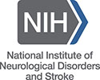
Hawaii Neuro COVID Research Laboratory
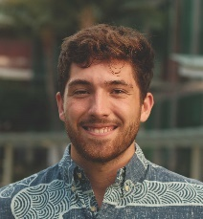
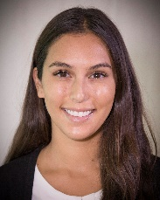
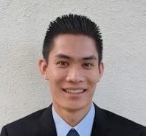
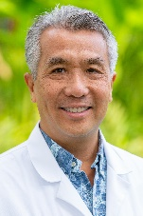
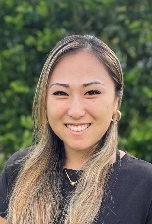
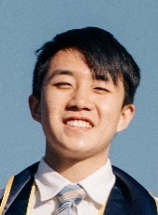
(Funded by NIH, NINDS Grant 3UL1TR002541-01S1)

Site Principal Investigator, Kore Liow, MD, Neurologist,
Director, Hawaii Neuro COVID Clinic,
Clinical Professor of Medicine (Neurology)
Research Assistants/Medical Students: Connor Goo (Lead), Hannah Bulosan,
Theodore Huo, Stephanie Matsuura, Edward Weldon IV
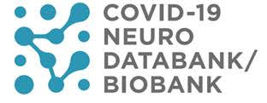
As of April 2022, Hawaii Neuro COVID Clinic is 1 of 16 US sites selected by NIH to serve as a participating site for the NeuoCOVID Project.

The NeuroCOVID project has been initiated at New York University Langone Health to create and maintain a national resource documenting and studying neurological complications of COVID-19 funded by NINDS, NIH National Center for Advancing Translational Sciences through its Clinical and Translational Science Awards Program.

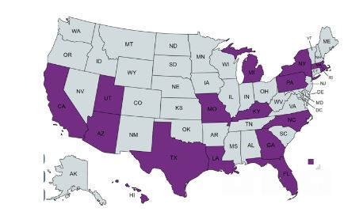
COVID-19 Neuro Databank: The databank will collect information on adults, children with confirmed COVID-19 infection to assess neurological symptoms such as fatigue, brain fog, headache, loss of smell & taste, pain, numbness, autonomic dysfunction and others.

COVID-19 Neuro Biobank: The biobank will collect a wide variety of biosamples, including blood, plasma, cerebrospinal fluid, and tissue, from patients who have COVID-19 and experience neurological complications.

More Information: Hawaii Neuro COVID Clinic or NIH website, NYU website

Hawaii Neuro COVID Research Laboratory
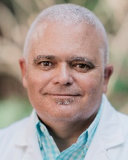
Lead Investigator, Enrique Carrazana, MD,
Neurologist & Publication director,
Clinical Educator of Medicine (Neurology)

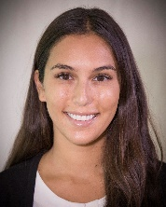
COVID-19 Olfactory Dysfunction: Differences in Prevalence Among Ethnicities & Variants in Hawaii NeuroCOVID Clinic
Research Assistants/Medical Students: Hannah Bulosan,
Olfactory dysfunction is widely known as one of the cardinal symptoms of COVID-19 infection. While earlier studies have suggested differences in anosmia between ethnic groups, the amount of available data at the time limited studies to compare primarily Asians and Caucasians. Since then, data regarding populations such as Africans and Latinos have been published and will be used to determine the prevalence of loss of smell as in a wider variety of groups. In addition to analyzing ethnic data, this study will also use epidemiological data regarding which strains of COVID-19 were prevalent in various regions throughout time in order to elucidate the impact of variants on anosmia.
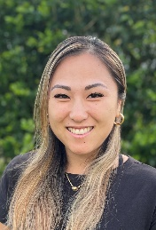
Diagnostic tools for evaluating long-covid-19 syndrome (LCS): a systematic review at Hawaii NeuroCOVID Clinic
Research Assistants/Medical Students: Stephanie Matsuura
Long Covid Syndrome (LCS) is becoming more and more prevalent across the world. Symptoms of LCS such as fatigue, shortness of breath and brain fog can be very debilitating for patients. Currently, there is no universal standard for evaluating and diagnosing LCS in patients. This review will look at the different methods and scales that have been used to evaluate LCS in previous studies and compare them to each other. The Review aims to make practical suggestions as to the use of scales for evaluating LCS for the researchers and practicing clinicians.
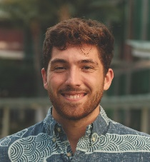
Exercise Intolerance Following COVID-19: Comparing and Contrasting Impact of Different Viral Infections
Research Assistants/Medical Students: Edward Weldon, I
Emerging literature continues to elucidate effects of COVID-19 that contribute to lasting exercise intolerance in many recovering patients. However, what is the severity and duration of these effects compared to other viral infections such as influenza and EBV? Is COVID-related exercise intolerance different than these other infections and how do the mechanisms create intolerance compare? By answering these questions, we hope that our research will better inform how to prevent and treat exercise intolerance both regarding COVID-19 and other viral infections.

COVID-19-Related Guillain-Barré Syndrome: Comparing Differences Between Variants and Other Viral Infection-Related Guillain-Barré Syndrome
Research Assistants/Medical Students: Theodore Huo
Since the emergence of the COVID-19 global pandemic, there has been evidence showing a relationship between Guillain-Barré syndrome (GBS) and COVID-19 infection. Our project seeks to compare GBS occurrence rates and severity among COVID-19 variants and across populations in different geographic locations. In assessing severity, we will investigate the occurrence of known GBS sequelae such as chronic inflammatory demyelinating polyradiculoneuropathy (CIPD). We will also compare COVID-19 GBS to GBS seen with other viral infections such as influenza A (H1N1), avian influenza, and zika virus.
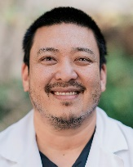
Neuromuscular Research Unit
Lead Investigator, Jason Chang, MD,
Physiatrist & Director, Neuromuscular Rehabilitation Center
Clinical Assistant Professor of Medicine (Neurology)

Investigating the Neuropathic Electromyography Findings in COVID-19 Patients
Research Assistants/Medical Students: Nathan Kim
COVID-19 is an acute infectious respiratory disease caused by infection with the SARS-CoV-2 virus. Although symptomatic patients with COVID-19 predominantly present with respiratory complaints, neurological manifestations have become increasingly recognized. However, the prevalence of these neurological complaints has been poorly quantified. A diagnostic procedure commonly utilized in the evaluation of patients with neuropathy is electromyography (EMG). Therefore, this study seeks to investigate the presence of neuropathic EMG findings in patients who previously contracted COVID-19.
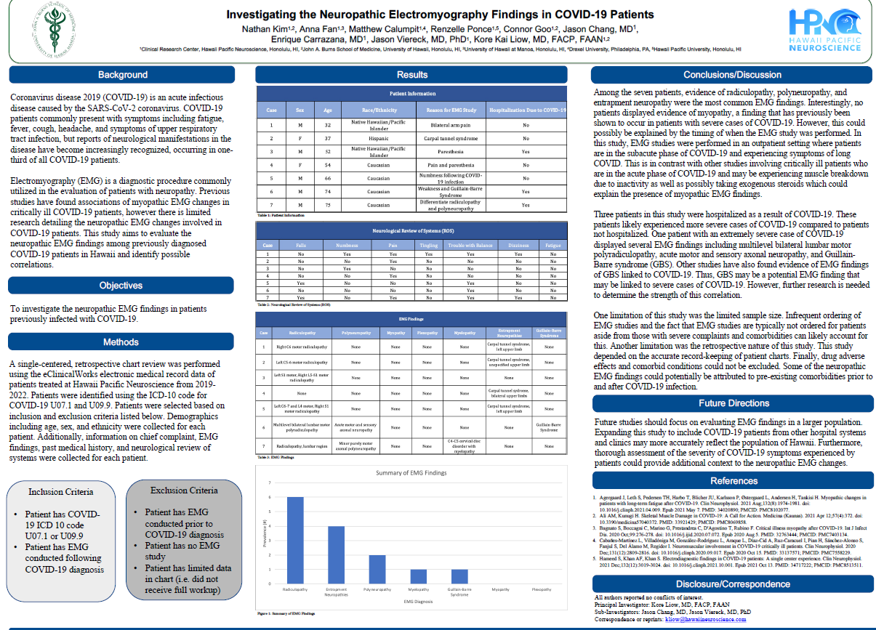
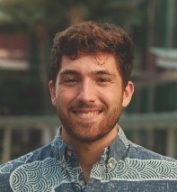
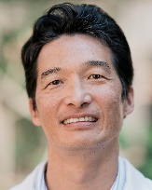
TBI Research Unit
Lead Investigator, Kent Yamamoto, MD
Physiatrist & Director, Concussion & TBI Center
Clinical Assistant Professor of Medicine (Neurology)

Can Mild to Moderate Exercise Modalities actually Enhance Recovery Following Traumatic Brain Injury? Research Assistants/Medical Students: Edward Weldon, I
Long standing literature has shown that contact sports and strenuous exercise should be avoided following traumatic brain injury (TBI).. The majority of this research focuses on treadmill aerobic exercise which may be jarring to the patient’s recovering brain. Furthermore, for patients with concurrent lower body injuries, treadmill exercise may not be possible. However, emerging literature indicates that some level of mild to moderate exercise may enhance patients’ recovery time. We aim to analyze TBI patients’ exercise modalities and patterns following TBI in order to identify effective exercises that improve symptoms and recovery time. Chart review to identify demographics, TBI severity, discharge from hospital time.
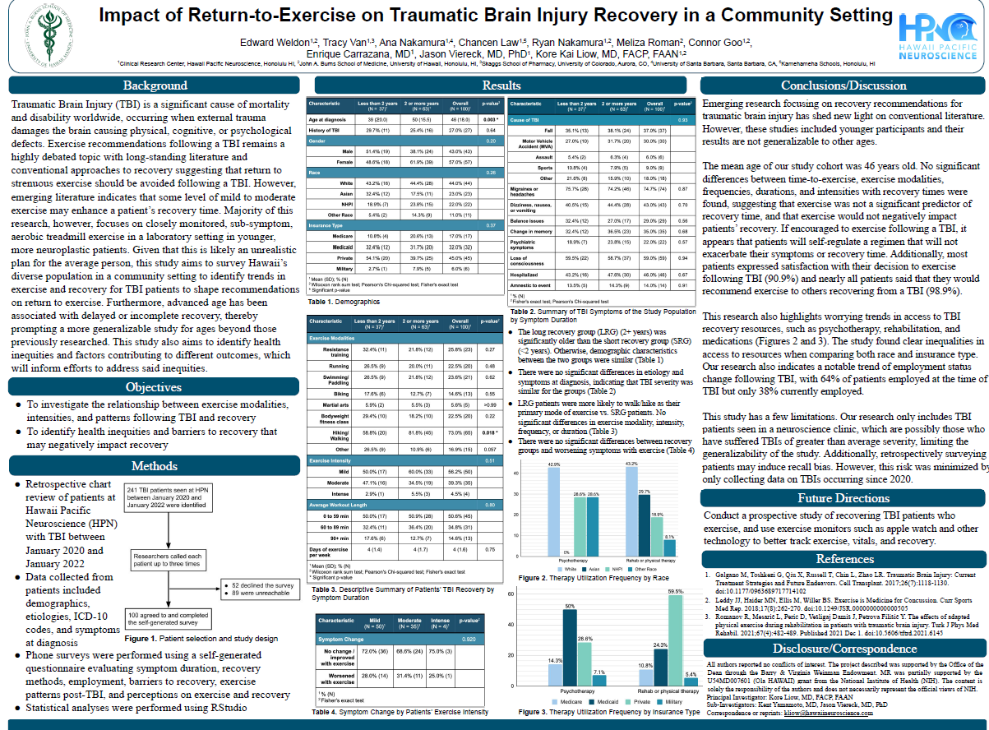

Sleep Research Unit
Lead Investigator, Sriharsha Vajjala, MD, Director, Sleep & Insomnia Center , Clinical Educator of Medicine (Neurology)
Research Assistants/Medical Students: Theodore Huo

Investigating CPAP Adherence Rates Among Sleep Apnea Patients in Hawaii
Continuous positive airway pressure (CPAP) is considered the gold standard treatment for patients with obstructive sleep apnea (OSA). Unfortunately, CPAP is known to be related to issues with adherence, with many patients abandoning the device or using it infrequently. However, adherence rates have not been described extensively in isolated, racially diverse island populations like those in Hawaii. The purpose of our project is to investigate CPAP adherence rates in Hawaii among patients with OSA who were treated at the Sleep and Insomnia Center at Hawaii Pacific Neuroscience
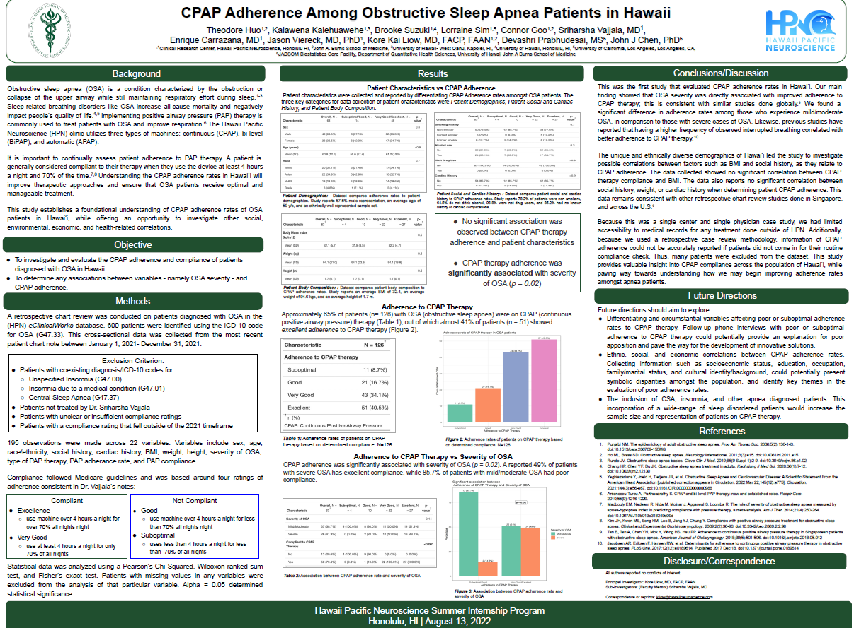
Parkinson’s Research Unit
Lead Investigator: Jason Viereck, MD, PhD,
Neurologist & Director, Parkinson’s & Movement Disorders Center,
Clinical Assistant Professor of Medicine (Neurology)
Research Assistants/Medical Students: ZoeAnn Kon
Does Parkinson’s Disease Patients with Depression have a Worse Outcome Compared to Those without Depression?
In patients with Parkinson’s disease (PD), depression is the most common psychiatric comorbidity and is often under-diagnosed and under-recognized. This can lead to worsened outcomes for patients and caregivers. To find the prevalence of depression in patients with PD at our institution using the Patient Health Questionnaire (PHQ-2). We retrospectively reviewed patients at the Hawaii Parkinson’s Disease & Movement Disorders with PD. Including patients on sleeping medications and antidepressants using two self-rating scales (Zung Self-rating Depression Scale and 15-item Geriatric Depression Scale).
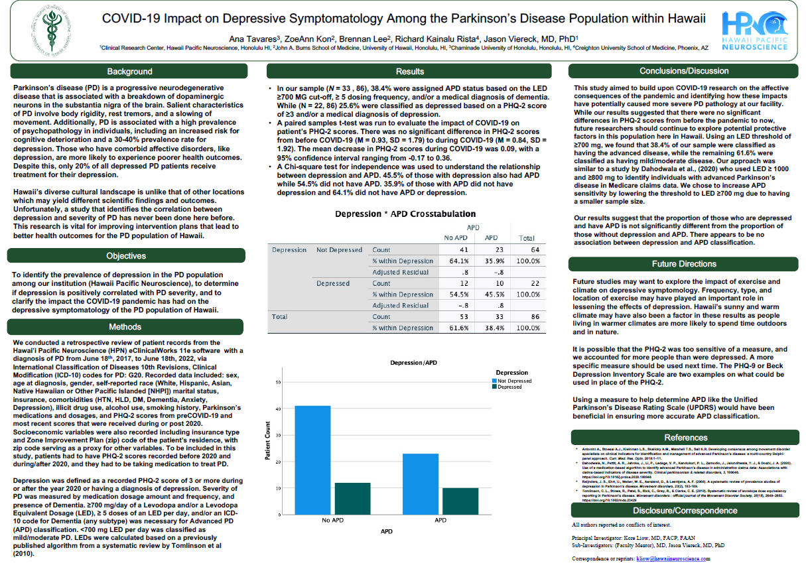
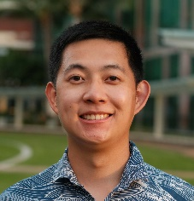
Alzheimer’s Research Unit
Lead Investigator, Kore Liow, MD,
Neurologist & Director, Memory Disorders Center
Clinical Professor of Medicine (Neurology)

Analyzing Barriers & Methods to Improve Clinical Trial Participation among Minority Population especially Asians and Native Hawaiian & Pacific Islands in Alzheimer’s Disease Research Research Assistants/Medical Students: Anson Lee
Alzheimer's disease (AD) is the most common neurodegenerative disorder in the United States and disproportionately burdens minority populations. However, clinical AD trials regularly face a shortage of eligible participants numbering in the thousands and this number is set to increase in the next several years. Previous research into barriers to clinical trial participation has found that economic constraints, structural and logistical obstacles, a lack of trust in medical institutions, or a scarcity of information about clinical trials, all negatively impact recruitment efforts. Amongst ethnic minority populations, Native Hawaiians and Pacific Islanders (NHPI), as well as Asians are the most underrepresented with Pacific islanders frequently found absent in AD clinical research. Minority representation is a key part of the generalizability of trial results, so identifying how ethnic minority engagement can be bolstered is crucial. This study explores the barriers to AD clinical trial participation in patients diagnosed with AD or mild cognitive impairment (MCI) in Hawai'i, the state with the largest relative population of Asian and NHPI individuals in the U.S.
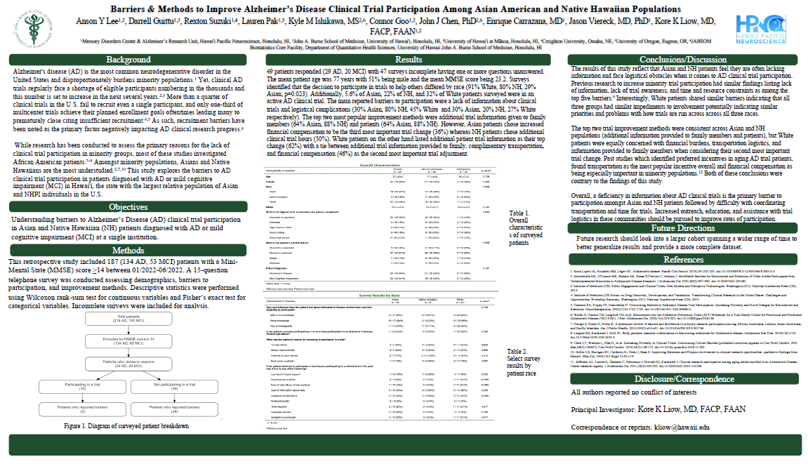

Headache Research Laboratory
Lead Investigator, Vimala Vajjala, MD,
Neurologist & Director, Headache & Facial Pain Center,
Clinical Educator of Medicine (Neurology)

Does Headaches Disrupt Quality of Life Different in Minority Population?
Research Assistants: Medical Students Michelle Lu
Headaches of all kinds, including tension headaches, cluster headaches, migraines, trigeminal neuralgia and headaches that are refractory to treatment can be extremely disruptive to patients’ quality of life, and occur more frequently in women of all races. We would like to examine the profiles of minority patients in Hawai’i and see whether they are characterized differently from white populations.
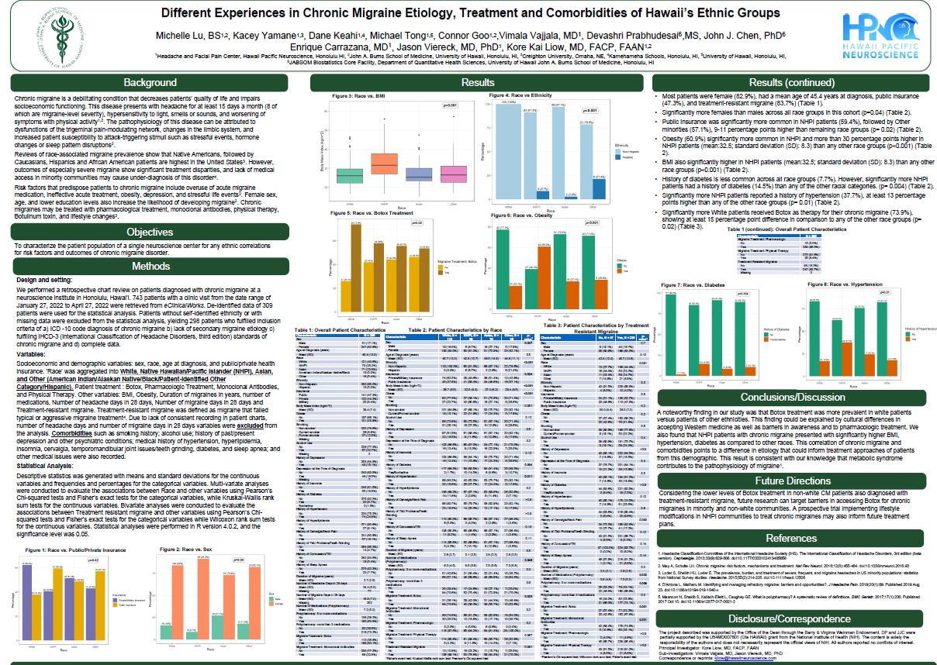

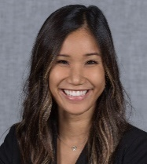
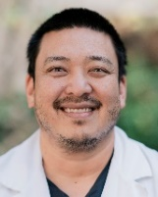
Pain Research Unit
Lead Investigator, Jason Chang, MD,
Physiatrist & Director, Spine & Pain Management Center
Clinical Assistant Professor of Medicine (Neurology)

Evaluating the Relationship Between Pain and Disability in Lumbar Radiculopathy Patients in Hawaii Undergoing Conservative Pain Treatment Research Assistants/Medical Students: Amanda Chau
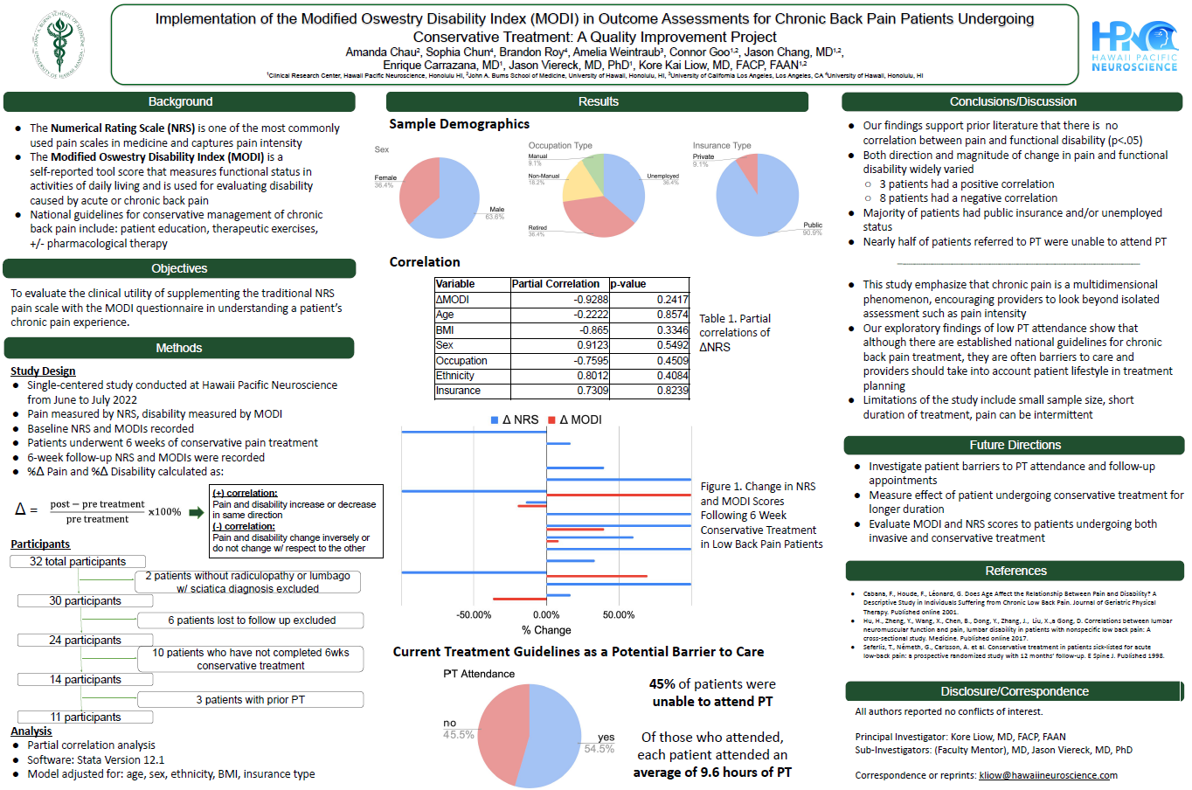
While the numeric rating scale (NRS) is a commonly used in assessing pain intensity, it only captures one dimension of a patient’s pain experience and may not necessarily reflect the extent of a patient’s resulting disability and their actual capacity to participate in daily activities. Can a patient with lumbar radiculopathy be completely rid of pain, yet still only gain back minimal functional capacity? This retrospective study will investigate the relationship between traditional NRS questionnaires and patients’ level of disability or dependence according to the Rankin Scale. Doing so can help us better identify patient outcomes related to functional capacity following conservative pain treatment in lumbar radiculopathy patients.

MS Research Unit
Lead Investigator: Jason Viereck, MD, PhD,
Neurologist & Director, Comprehensive MS Center,
Clinical Assistant Professor of Medicine (Neurology)

Investigating the Prevalence of Psychiatric Disorders in MS Patients with Immune Comorbidities? Research Assistants/Medical Students: Shin Chang
The immune system plays a vital role in the onset and progression of multiple sclerosis (MS). Studies have shown that certain immune comorbidities such as Hashimoto’s thyroiditis, Type I diabetes, and psoriasis are more prevalent in patients with MS. Other studies have also indicated a higher rate of anxiety and depression among patients with MS. In this study, we will research the patterns of immune comorbidities in patients with MS and how they may correlate with diagnoses of depression and anxiety.
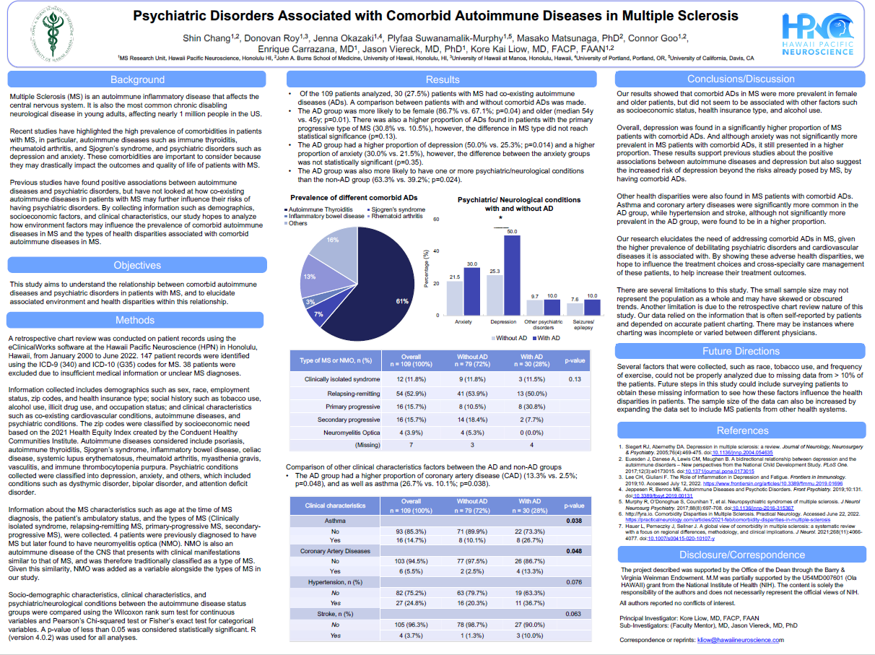

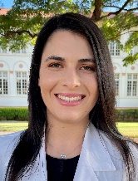
Epilepsy Research Unit
Lead Investigator, Vimala Vajjala, MD,
Neurologist, Comprehensive Epilepsy Center
Clinical Educator of Medicine (Neurology)

Investigating the Etiologies of Seizures in Patients Undergoing Video-EEG at Hawaii Comprehensive Epilepsy Center Research Assistant/ Medical Students: Julia Jahansooz
Routine electroencephalograms (EEG) are a first-line diagnostic tool used to detect abnormalities in brain waves. Outpatient Video-EEG monitoring (vEEG) is a more extensive, multi-day procedure that helps to determine the cause of these abnormalities. The distribution of etiologies of Hawaii Comprehensive Epilepsy Center patients who underwent an vEEG is currently unknown. This project aims to identify the percentage of patients with vEEG abnormalities and whether they experienced an epileptic versus a non-epileptic event. Other factors that will be considered include age, gender, duration of epilepsy, types of seizures, and number of anti-epileptic drugs (AED) used.
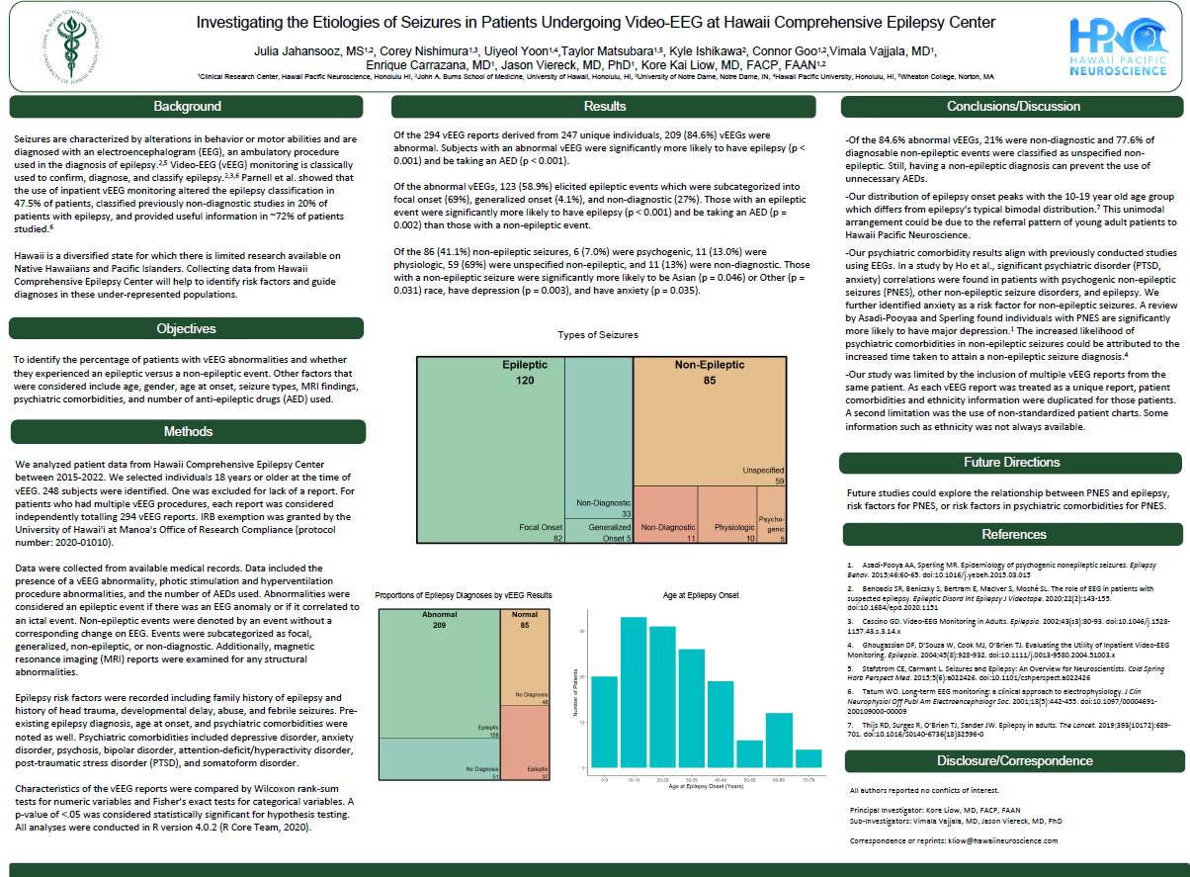
Neuromodulation & Brain Computer Interface Laboratory
Lead Investigator, Kore Liow, MD,
Neurologist & Director, Hawaii Center for Neuromodulation
Clinical Professor of Medicine (Neurology)
Research Assistants/Medical Students: ZoeAnn Kon

Is Neuromodulation like Vagal Nerve Stimulator Improving the Quality of Life, Reducing HealthCare Utilization in Geographic Island State like Hawaii?
Neuromodulation-based therapies such as vagal nerve stimulation (VNS) is used for patients with refractory epilepsy. Many studies have shown VNS reduces seizure frequency and the impact on quality of life (QOL) in patients implanted with VNS treatment in many epilepsy centers. However, the efficacy, utilization and QOL of life in VNS patients has not been looked at in geographic isolated island populations like those in the state of Hawaii and whether they are any different from other epilepsy centers. Our project seeks to investigate the efficacy, utilization and QOL impacts of patients implanted with VNS at the Hawaii Comprehensive Epilepsy Center and Hawaii Center for Neuromodulation.

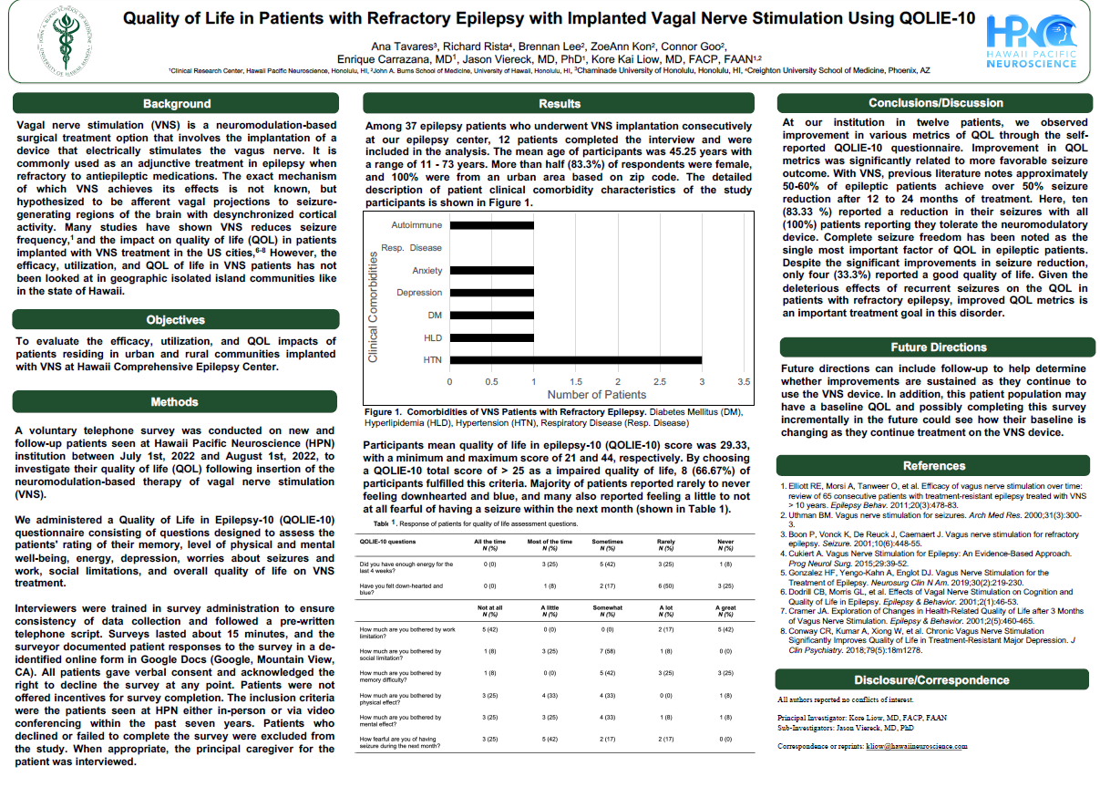

Clinical Research Center
Brain Research, Innovation & Translation Laboratory (BRITL)

Recent Publications & National Presentations

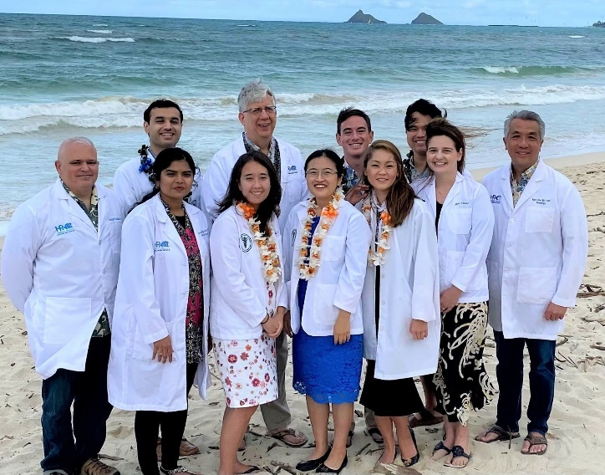
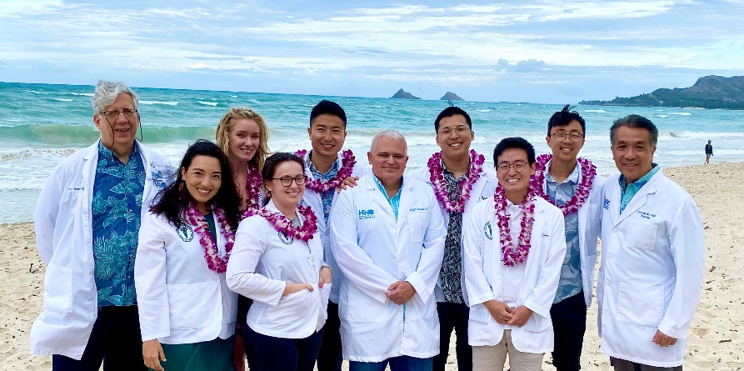
2021 Graduating Hawaii BRITL Scholars 2022 Graduating Hawaii BRITL Scholars

Student or Resident Involved PubMed Peer Reviewed Neuroscience Publications
Chang BK, Adlawan J, Fesenmeier S, Kaminskas D, Carrazana E, Liow KK. A Rare Presentation of Central Nervous System Tuberculomas in an Immunocompetent Patient. Hawaii J Health Soc Welf. 2022 Jun;81(6):151-154. PMID: 35673365; PMCID: PMC9168935.

Cori Xiu Yue Sutton, Enrique Carrazana, Catherine Mitchell, Jason Viereck, Kore Kai Liow, Arash Ghaffari-Rafi, Identification of associations and distinguishing moyamoya disease from ischemic strokes of other etiologies: A retrospective case-control study, Annals of Medicine and Surgery, Volume 78,2022,103771, ISSN 2049-0801, https://doi.org/10.1016/j.amsu.2022.103771

Gorenflo R, Ho R, Carrazana E, Mitchell C, Viereck J, Liow KK, Ghaffari-Rafi A. Identification of risk factors and distinguishing psychogenic nonepileptic seizures from epilepsy: A retrospective case-control study. Clin Neurol Neurosurg. 2022 Mar 31;217:107221. doi: 10.1016/j.clineuro.2022.107221. Epub ahead of print. PMID: 35429851.

Ogasawara R, Kang E, Among J, Oyadomari K, Capitaine J, Regaspi N, Borman P, Viereck J, Carrazana E, Liow KK. Native Hawaiian and other pacific islanders' leading risk factors for ischemic stroke: A comparative ethnographic study. J Stroke Cerebrovasc Dis. 2022 Mar 24;31(6):106433. doi: 10.1016/j.jstrokecerebrovasdis.2022.106433. PMID: 35339856

Crocker J, Liu K, Smith M, Nakamoto M, Mitchell C, Zhu E, Ma E, Morden FT, Chong A, Van N, Dang N, Borman P, Carrazana E, Viereck J, Liow KK. Early Impact of the COVID-19 Pandemic on Outpatient Neurologic Care in Hawai'i. Hawaii J Health Soc Welf. 2022 Jan;81(1):6-12. PMID: 35028589; PMCID: PMC8742305.

Ghaffari-Rafi A, Teehera KB, Higashihara TJ, Morden FTC, Goo C, Pang M, Sutton CXY, Kim KM, Lew RJ, Luu K, Yamashita S, Mitchell C, Carrazana E, Viereck J, Liow KK. Variables Associated with Coronavirus Disease 2019 Vaccine Hesitancy Amongst Patients with Neurological Disorders. Infect Dis Rep. 2021 Aug 30;13(3):763-810. doi: 10.3390/idr13030072. PMID: 34562997; PMCID: PMC8482072.

Smith M, Van N, Roberts A, Hosaka KRJ, Choi SY, Viereck J, Carrazana E, Borman P, Chen JJ, Liow KK. Disparities in Alzheimer Disease and Mild Cognitive Impairment Among Native Hawaiians and Pacific Islanders. Cogn Behav Neurol. 2021 Sep 2;34(3):200-206. doi: 10.1097/WNN.0000000000000279.
PubMed PMID: 34473671.

Morden FTC, Tan C, Carrazana E, Viereck J, Liow KK, Ghaffari-Rafi A. Characterizing idiopathic intracranial hypertension socioeconomic disparities and clinical risk factors: A retrospective case-control study. Clin Neurol Neurosurg. 2021 Aug 14;208:106894
PMID: 34455402.

Toni T, Tamanaha R, Newman B, Liang Y, Lee J, Carrazana E, Vajjala V, Viereck J, Liow KK. Effectiveness of dual migraine therapy with CGRP inhibitors and onabotulinumtoxinA injections: case series. Neurol Sci. 2021 Aug 18. doi: 10.1007/s10072-021-05547-x.
PMID: 34409517 https://link.springer.com/article/10.1007%2Fs10072-021-05547-x

Ko AWK, Ghaffari-Rafi A, Chan A, Harris WB, Imasa A, Liow KK, Viereck J. A Case Report of Antibiotic-Induced Aseptic Meningitis in Psoriasis. Hawaii J Health Soc Welf. 2021 Jun;80(6):129-133.
PubMed PMID: 34195619; PubMed Central PMCID: PMC8237324.Online PDF Access

Smith M, Nakamoto M, Crocker J, Tiffany Morden F, Liu K, Ma E, Chong A, Van N, Vajjala V, Carrazana E, Viereck J, Liow K. Early impact of the COVID-19 pandemic on outpatient migraine care in Hawaii: Results of a quality improvement survey. Headache. 2020 Dec 14;. doi: 10.1111/head.14030.
PubMed PMID: 33316097.

Nakamoto M, Carrazana E, Viereck J, Liow K. Epilepsy in the time of COVID-19. Acta Neurol Scand. 2020 Oct 11;. doi: 10.1111/ane.13360. [Epub ahead of print]
PubMed PMID: 33043445; PubMed Central PMCID: PMC7675556.

Ghaffari-Rafi A, Gorenflo R, Hu H, Viereck J, Liow K. Role Of Psychiatric, Cardiovascular, Socioeconomic, And Demographic Risk Factors On Idiopathic Normal Pressure Hydrocephalus: A Retrospective Case-Control Study. Clin Neurol Neurosurg. 2020 Jun;193:105836. doi: 10.1016/j.clineuro.2020.105836. Epub 2020 Apr 28.
PubMed PMID: 32371292.

Smith M, Wicknick A, Liow KK. Medical School Hotline: Hawai'i Pacific Neuroscience Summer Internship Program. Hawaii J Health Soc Welf. 2020 Mar 1;79(3):82-85. PubMed PMID: 32190840; PubMed Central PMCID: PMC7061031.

Ho R, Ocol J, Lu C, Dolim S, Yang M, Carrazana E, Liow KK. Presentation of psychogenic nonepileptic seizures in Hawaii's ethnoracially diverse population. Epilepsy Behav. 2019 Jul;96:150-154. doi: 10.1016/j.yebeh.2019.04.024. Epub 2019 May 28.
PubMed PMID: 31146179

Lew WJ, Tsai WY, Balaraman V, Liow KK, Tyson J, Wang WK. Zika Virus: Relevance to the State of Hawai'i. Hawaii J Med Public Health. 2019 Apr;78(4):123-127.
PubMed PMID: 30972234; PubMed Central PMCID: PMC6452016.

Beckwith NL, Khil JC, Teng J, Liow KK, Smith A, Luna J. Inappropriate Laughter and Behaviours: How, What, and Why? Case of an Adult with Undiagnosed Gelastic Seizure with Hypothalamic Hamartoma. Hawaii J Med Public Health. 2018 Dec;77(12):319-324. PubMed PMID: 30533284; PubMed Central PMCID: PMC6277842.
Student or Resident Involved National & International Neuroscience Presentations
Evaluating Whether EEG Could Predict Alzheimer’s Disease Onset in Preclinical Patients with the ApoE4 Allele: An Update. Kim N, Tan C, Ma E, Kutlu S, Mitchell C, Carrazana E, Viereck J, Vajjala V, Liow K. 2022 American Epilepsy Society Meeting, Nashville, TN December 2022

Employability, Work Difficulties and Factors Impacting Chronic Migraine Patients of Hawaii: Results of a Quality Improvement Survey, Michelle Stafford, Tracy Van, Rachel Gorenflo, Frances Morden, Kara Ushijima, Ashley Ung, Emma Inouye, Uiyeol Yoon, Dr. Vimala Vajjala, Dr. Enrique Carrazana, Dr. Kore Liow. American Academy of Neurology Annual Meeting, Seattle, WA, April 2022.

Influence of Ethnoracial and Sociodemographic Variables on Incidence and Management of Traumatic Brain Injury Patients in Hawaii. Kayti Luu, Michelle Pang, Rachel Gorenflo, Frances Morden, Ariel Ma, Nicholas Sims, Lauren Fujii, Kent Yamamoto, Enrique Carrazana, Jason Viereck, Kore Liow, American Academy of Neurology Annual Meeting, Seattle, WA, April 2022.

Association of Mechanism of Injury and Clinical Presentation of Patients with Traumatic Brain Injury in Hawai’i. Michelle Pang, Kayti Luu, Frances Morden, Rachel Gorenflo, Ariel Ma1, Nicholas Sims, Lauren Fujii, Kent Yamamoto, Enrique Carrazana, Jason Viereck, Kore Kai Liow. American Association of Neurological Surgeons (AANS) Annual Scientific Meeting,
Philadelphia, PA, USA. April 2022.

Identifying Familiarity and Knowledge Of Aducanumab In Caregivers Of Hawaii Alzheimerʼs Disease Patients. C. Goo, F. Morden, S. Aquino, K. Wong, J. Kawamura, S. Masca, R. Gorenflo , P. Borman, E. Carrazana, J. Viereck, K. Liow. 16th International Conference on Alzheimer’s & Parkinson’s Diseases, Barcelona, Spain. March 15-20, 2022

Systematic Review of Recruitment Bias in U.S. Phase 2 and 3 Randomized Clinical Trials of Cancer & Chemotherapy in Adults: 2008-2019. Buffenstein, I, Taylor E, Kāneakua, B, Matsunaga, M., Choi SY, Carrazana E, Liow, K, Viereck,J, Ghaffari-Rafi A. International Cancer Education Conference, Virtual, October 12-16, 2021

Buffenstein I., Tan C., Linna J., Masca A., Kayumova R., Ragheb J., Gorenflo R., Chang J., Carrazana E., Viereck J., Morden F., Liow K. “Sociodemographic Disparities of Patients with Lumbar Radiculopathy: A Single-Centered Retrospective Study.” 2022 Association of Academic Physiatrists Annual Scientific Meeting, New Orleans, Feb 2022.

Sociodemographic and Biological Differences Between Traumatic Brain Injury Patients Of Different Ethnoracial Groups Michelle Pang, Kayti Luu, Rachel Gorenflo, Frances Morden, Ariel Ma, Nicholas Sims, Lauren Fujii, Kent Yamamoto, Enrique Carrazana, Jason Viereck, Kore Kai Liow. 2022 Association of Academic Physiatrists Annual Scientific Meeting, New Orleans, Feb 2022.

Evaluating Whether EEG could Predict Alzheimer's Disease Onset in Preclinical Patients with the ApoE4 Allele Ma E, Kutlu S, Kim N, Mitchell C, Vajjala V, Carrazana E, Viereck J, Liow K 2021 AAIC (Alzheimer's Association International Conference), Denver, CO, Wednesday 2021 July 26th
Demographic Bias in Opioid Use Disorder Clinical Trials. Buffenstein, I, Taylor E, Kāneakua, B, Carrazana E, Liow, K, Viereck,J, Ghaffari-Rafi A. American Medical Association Research Challenge. Virtual Conference, December 2021

Psychiatric, and Biological Risk Factors in Psychogenic Nonepileptic Seizures. Gorenflo R, Ho R, Viereck J, Mitchell C, Carrazana E, Liow KK, Ghaffari-Rafi A, Identifying Socioeconomic, 25th World Congress of Neurology. Annual Scientific Meeting, Rome, Italy. October 3-7, 2021

Comparing Epilepsy to Psychogenic Non-Epileptic Seizures, Identification of Risk Factors: A Retrospective Case-Control Study. Ho R, Gorenflo R, Viereck J, Mitchell C, Carrazana E, Liow KK, Ghaffari-Rafi. 25th World Congress of Neurology. Annual Scientific Meeting, Rome, Italy. October 3-7, 2021

Sociodemographic Disparities and Risk Factors in Diagnosing Idiopathic Intracranial
Hypertension: A Retrospective Case-Control Study. Frances Morden Charissa Tan, Enrique Carrazana, Jason Viereck, Kore Kai Liow, Arash Ghaffari-Rafi. American Association of Neurological Surgeons, Annual Scietific Meeting, Orlando, FL, August 2021

Assessing U.S. Demographic Recruitment Bias in 21st Century Neurosurgery Clinical Trials. Taylor E, Buffenstein I, Kāneakua B, Ghaffari-Rafi A, Viereck J, Carrazana E, Liow K. American Association of Neurological Surgeons, Annual Scientific Meeting, Orlando, FL, August 2021

Factors that Affect the Employability of Patients with Epilepsy in Hawaii: A Look at Race, Comorbidities, and Marital Status. Gorenflo R, Kimball L, Taeza B, Gan A, Viereck J, Carrazana E, Liow K. American Academy of Neurology Annual Meeting, April 2021

Effectiveness of Dual Migraine therapy with CGRP Antagonists and OnabotulinumtoxinA Injections: Experience from a Single Migraine Center in Hawaii. Lee J, Liang Y, Newman B, Tamanaha R, Toni T, Carrazana E, Vajjala V, Viereck J, Liow K. 2020 International Headache Society Annual Meeting

COVID-19 Pandemic Effect on Epilepsy Outpatient Care at a Regional Referral Center in Hawaii. Nakamoto M, Smith M, Crocker J, Morden F, Liu K, Ma E, Chong A, Van N, Mitchell C, Zhu E, Dang N, Carrazana E, Viereck J, Liow K. 74th Annual Meeting of the American Epilepsy Society Meeting, Seattle, WA, Dec 2020.

Use of Cannabinoids in Patients with Epilepsy from a Comprehensive Epilepsy Center in Hawaii. R Ho, J Zhang, C Lu, B Fong, K Oura, A Shipman, H Hu, A Appana, G Slattery, E Carrazana , K Liow, American Epilepsy Society Annual Meeting, Baltimore, MD, Dec, 2019

Biopsychological predictors in patients with psychogenic non-epileptic seizures from a comprehensive epilepsy center in Hawai'i, ,C Lu, R Ho, J Ocol, M Yang, E Carrazana, K Liow American Epilepsy Society Annual Meeting, Baltimore, MD, Dec, 2019

Presentation of PNES in Hawaii’s Ethnoculturally Diverse Patients. American Epilepsy Society Meeting, New Orleans, LA. December 2018.

Neuroscience Faculty PubMed Publications
Fang, C., Hernandez, P., Liow, K. et al. Buntanetap, a Novel Translational Inhibitor of Multiple Neurotoxic Proteins, Proves to Be Safe and Promising in Both Alzheimer’s and Parkinson’s Patients. J Prev Alzheimers Dis (2022). https://doi.org/10.14283/jpad.2022.84

Rademacher, M, Toledo, M, Van Paesschen, W, Liow, KK, Milanov, IG, Esch, M-L, et al. Efficacy and safety of adjunctive padsevonil in adults with drug-resistant focal epilepsy: Results from two double-blind, randomized, placebo-controlled trials. Epilepsia Open. 2022; 00: 1– 13. https://doi.org/10.1002/epi4.12656

Sperling MR, Wheless JW, Hogan RE, Dlugos D, Cascino GD, Liow K, Rabinowicz AL, Carrazana E; DIAZ 001.05 Study Group. Use of second doses of Valtoco® (diazepam nasal spray) across 24 hours after the initial dose for out-of-hospital seizure clusters: Results from a phase 3, open-label, repeat-dose safety study. Epilepsia. 2022 Apr;63(4):836-843. doi: 10.1111/epi.17177. Epub 2022 Feb 2. PMID: 35112342.

Mignot E, Mayleben D, Fietze I, Leger D, Zammit G, Bassetti CLA, Pain S, Kinter DS, Roth T; investigators. Safety And Efficacy Of Daridorexant In Patients With Insomnia Disorder: Results From Two Multicentre, Randomised, Double-Blind, Placebo-Controlled, Phase 3 Trials. Lancet Neurol. 2022 Feb;21(2):125-139. doi: 10.1016/S1474-4422(21)00436-1. Erratum in: Lancet Neurol. 2022 Jan 20;:
PMID: 35065036.

French JA, Cole AJ, Faught E, Theodore WH, Vezzani A, Liow K, Halford JJ, Armstrong R, Szaflarski JP, Hubbard S, Patel J, Chen K, Feng W, Rizzo M, Elkins J, Knafler G, Parkerson KA; OPUS Study Group. Safety and Efficacy of Nataluzimab as Adjunctive Therapy for People With Drug-Resistant Epilepsy: A Phase 2 Study. Neurology. 2021 Sep 14:10.1212/
PMID: 34521687.

Wheless JW, Miller I, Hogan RE, Dlugos D, Biton V, Cascino GD, Sperling MR, Liow K, Vazquez B, Segal EB, Tarquinio D, Mauney W, Desai J, Rabinowicz AL, Carrazana E; DIAZ.001.05 Study Group. Final results from a Phase 3, long-term, open-label, repeat-dose safety study of diazepam nasal spray for seizure clusters in patients with epilepsy. Epilepsia. 2021 Aug 21. doi: 10.1111/epi.17041.
PMID: 34418086. https://onlinelibrary.wiley.com/doi/epdf/10.1111/epi.17041

Cascino GD, Tarquinio D, Wheless JW, Hogan RE, Sperling MR, Liow K, Desai J, Davis C, Rabinowicz AL, Carrazana E. Lack of observed tolerance to diazepam nasal spray (Valtoco®) after long-term rescue therapy in patients with epilepsy: Interim results from a phase 3, open-label, repeat-dose safety study. Epilepsy Behav. 2021 May 3;120:107983. doi: 10.1016/j.yebeh.2021.107983
PubMed PMID: 33957437 Online Full Text PDF Link

Segal EB, Tarquinio D, Miller I, Wheless JW, Dlugos D, Biton V, Cascino GD, Desai J, Hogan RE, Liow K, Sperling MR, Vazquez B, Cook DF, Rabinowicz AL, Carrazana E. Evaluation of diazepam nasal spray in patients with epilepsy concomitantly using maintenance benzodiazepines: An interim subgroup analysis from a phase 3, long-term, open-label safety study. Epilepsia. 2021 May 4;. doi: 10.1111/epi.16901.
PubMed PMID: 33942315. Open Access Online PDF

Miller I, Wheless JW, Hogan RE, Dlugos D, Biton V, Cascino GD, Sperling MR, Liow K, Vazquez B, Segal EB, Tarquinio D, Mauney W, Desai J, Rabinowicz AL, Carrazana E. Consistent safety and tolerability of Valtoco® (diazepam nasal spray) in relationship to usage frequency in patients with seizure clusters: Interim results from a phase 3, long-term, open-label, repeat-dose safety study. Epilepsia Open. 2021 May 5;. doi: 10.1002/epi4.12494. Online Access
PubMed PMID: 34033266

Nair DR, Laxer KD, Weber PB et al. Nine-Year Prospective Efficacy And Safety Of Brain-Responsive Neurostimulation For Focal Epilepsy. Neurology. 2020 Sep 1;95(9):e1244-e1256. doi: 10.1212/WNL.0000000000010154. Epub 2020 Jul 20.
PubMed PMID: 32690786; PubMed Central PMCID: PMC7538230.

Hauser SL, Bar-Or A, Cohen JA, Comi G, Correale J, Coyle PK, Cross AH, de Seze J, Leppert D, Montalban X, Selmaj K, Wiendl H, Kerloeguen C, Willi R, Li B, Kakarieka A, Tomic D, Goodyear A, Pingili R, Häring DA, Ramanathan K, Merschhemke M, Kappos L. Ofatumumab versus Teriflunomide in Multiple Sclerosis. N Engl J Med. 2020 Aug 6;383(6):546-557. doi: 10.1056/NEJMoa1917246.
PubMed PMID: 32757523.

Meador KJ, Pennell PB, May RC, Brown CA, Baker G, Bromley R, Loring DW, Cohen MJ. Effects of periconceptional folate on cognition in children of women with epilepsy: NEAD study. Neurology. 2020 Feb 18;94(7):e729-e740. doi: 10.1212/WNL.0000000000008757. Epub 2019 Dec 23. PubMed PMID: 31871217; PubMed Central PMCID: PMC7176294.
Neuroscience Faculty National or International Presentations
Safety and Time to Second Doses in Pediatric and Adult Patients With Seizure Clusters Treated With Diazepam Nasal Spray in a Phase 3, Open-Label, Repeat-Dose Safety Study. James W. Wheless, R. Edward Hogan, Michael R. Sperling, Kore Liow, Daniel Tarquinio, Jay Desai, Dennis Dlugos, Gregory D. Cascino, Enrique Carrazana, and Adrian L. Rabinowicz, for the DIAZ.001.05 Study Group. 2nd North American Epilepsy Congress, May 2022

Timing to Administration and Ease of Dosing of Diazepam Nasal Spray Rescue Therapy for Seizure Clusters: Results from a Phase 3, Long-Term Open-Label, Repeat-Dose Safety Study. Jay Desai, MD; R. Edward Hogan, MD; James W. Wheless, MD; Michael R. Sperling, MD; Kore Liow, MD; Daniel Tarquinio; Dennis Dlugos, MD; Gregory D. Cascino, MD; Sunita N. Misra, MD, PhD; Adrian L. Rabinowicz, MD; and Enrique Carrazana, MD for the DIAZ.001.05 Study Group. American Academy of Neurology Annual Meeting, Seattle, WA, April 2022.

Safety of a Second Dose of Diazepam Nasal Spray Within 4 Hours in Patients with Seizure Clusters: Final Results From a Long-Term, Phase 3, Open-Label, Repeat-Dose Safety Study. Gregory D. Cascino, MD; Jay Desai, MD2; Daniel Tarquinio, DO; James W. Wheless, MD; R. Edward Hogan, MD; Michael R. Sperling, MD; Kore Liow, MD; Sunita N. Misra, MD, PhD; Enrique Carrazana, MD; and Adrian L. Rabinowicz, MD for the DIAZ.011.05 Study Group. American Academy of Neurology Annual Meeting, Seattle, WA, April 2022.

Positive Clinical Outcomes in Two Phase 2a Studies; ADAS-Cog in Alzheimer’s and UPDRS in Parkinson’s patients plus Markers of Toxic Cascade that Leads to Nerve Cell Death

2021 Alzheimer's Association International Conference, Denver, CO, Wednesday July 26th

Safety Profile of Valtoco® (diazepam nasal spray) in Patients with Epilepsy: Final Results From a Phase 3, Open-Label, 12-Month Repeat Dose Safety Study. Wheless JW, Sperling MR, Liow K, Vazquez B, Segal EB, Miller I, Hogan RE, Tarquinio D, Mauney W, DeSai J, Dlugos D, Biton V, Cascino G, Carrazana E; Rabinowicz AL, for the DIAZ.001.05 Study Group. American Managed Care Pharmacist (AMCP) Annual Meeting, Virtual. April 2021

Time to Second Doses in Emergency Seizure Patients Treated with Valtoco® (diazepam nasal spray) Across 24 Hours: Subgroup Results From a Completed Phase 3, Open-label, Repeat Dose Safety Study. Wheless JW, Sperling MR, Liow K, Vazquez B, Segal EB, Miller I, Hogan RE, Tarquinio D, Mauney W, DeSai J, Dlugos D, Biton V, Cascino G, Carrazana E; Rabinowicz AL, for the DIAZ.001.05 Study Group. American Managed Care Pharmacist (AMCP) Annual Meeting, Virtual. April 2021

Evaluation of Diazepam Nasal Spray in Patients with Epilepsy Concomitantly Using Maintenance Benzodiazepines: Interim Analysis from a Phase 3, Long-term, Open-label Safety Study. Segal E, Tarquinio D, Miller I, Wheless J, Dlugos D, Biton V, Cascino G, Desai J, Hogan E, Liow K, Mauney W, Sperling M, Cook D, Rabinowicz A, Carrazana E, for the DIAZ.001.05 Study Group. American Academy of Neurology (AAN), Annual Meeting, Virtual. April 2021

Safety Profile of Valtoco® (diazepam nasal spray) in Patients With Epilepsy: Final Results From a Phase 3, Open-Label, 12-Month Repeat Dose Safety Study. Wheless JW, Sperling MR, Liow K, Vazquez B, Segal EB, Miller I, Hogan RE, Tarquinio D, Mauney W, DeSai J, Dlugos D, Biton V, Cascino G, Carrazana E; Rabinowicz AL, for the DIAZ.001.05 Study Group. American Academy of Neurology (AAN), Annual Meeting, Virtual. April 2021

Time to Second Doses in Emergency Seizure Patients Treated with Valtoco® (diazepam nasal spray) Across 24 Hours: Subgroup Results From a Completed Phase 3, Open-label, Repeat Dose Safety Study. Wheless JW, Sperling MR, Liow K, Vazquez B, Segal EB, Miller I, Hogan RE, Tarquinio D, Mauney W, DeSai J, Dlugos D, Biton V, Cascino G, Carrazana E; Rabinowicz AL, for the DIAZ.001.05 Study Group. American Academy of Neurology (AAN), Annual Meeting, Virtual. April 2021

Use of a Second Dose of Diazepam Nasal Spray Within 4 Hours and Effect on the Safety Profile in Patients with Seizure Clusters: Interim Results from a Phase 3, Open-Label, 12-Month Repeat Dose Safety Study. Daniel Tarquinio, Eric B. Segal, Ian Miller, James W. Wheless, R. Edward Hogan, Victor Biton, Gregory D. Cascino, Michael R. Sperling, Kore Liow, Blanca Vazquez, Ricardo Ayala, Weldon Mauney, Jay Desai, Adrian L. Rabinowicz, Enrique Carrazana, for the DIAZ.001.05 Study Group. 74th Annual Meeting of the American Epilepsy Society Meeting, Seattle, WA, Dec 2020.

Evaluation of Diazepam Nasal Spray in Patients with Epilepsy Concomitantly Using Maintenance Benzodiazepines: Interim Analysis from a Phase 3, Long-term, Open-label Safety Study. Eric B. Segal, ; Daniel Tarquinio, Ian Miller, James W. Wheless, Dennis Dlugos, Ricardo Ayala,Victor Biton, Gregory D. Cascino, Jay Desai, R. Edward Hogan, Kore Liow, Weldon Mauney, Michael R. Sperling, Blanca Vazquez, David F. Cook, Adrian L. Rabinowicz, Enrique Carrazana for the DIAZ.001.05 Study Group. 74th Annual Meeting of the American Epilepsy Society Meeting, Seattle, WA, Dec 2020.

Efficacy and Safety Of Adjunctive Padsevonil In Adults With Drug-Resistant Focal Seizures: A Double-Blind, Randomized, Placebo-Controlled Dose-Finding Trial. Rademacher M, Toledo M, Van Paesschen W, Liow K, Esch M, Webster E, Wang N, Werhahn K, French J. 74th Annual Meeting of the American Epilepsy Society Meeting, Seattle, WA, Dec 2020.

Vagal Nerve Stimulation (VNS) in genetic developmental epileptic encephalopathies (DEE):
approach in highly specialized centers around the world. Kwan P, Verner R, O'Brien T, El Tahry R, Keough K, Boggs J, Fahoum F, Greco T, Van Grunderbeek W, Sen A,Core-VNS Study Group. 2020 74th Annual Meeting of the American Epilepsy Society Meeting, Seattle, WA, Dec 2020.

CORE-VNS: A Prospective Outcomes Registry of Patients With Drug-resistant Epilepsy Treated With Vagus Nerve Stimulation Therapy. Kwan P, Verner R, O'Brien T, El Tahry R, Keough K, Boggs J, Fahoum F, Greco T, Van Grunderbeek W, Sen A,Core-VNS Study Group. 2020 74th Annual Meeting of the American Epilepsy Society Meeting, Seattle, WA, Dec 2020.

A Randomized Phase 3 Study in Mild Alzheimer’s Disease (DAYBREAK-ALZ). Sims JR, Zimmer J, Wessels A, Selzler K, Andersen SW, Landry J, Mullen J, Barker P, Stern R, Vellas B, Boada M, Cohen S, MacSweeny E, Tariot P. Lanabecestat. 14th International Conference on Alzheimer's and Parkinson's Disease (ADPD) 2019.

Willis B, James D, Scott S, Bragg S, Mullen J, Downing A, Selzler K, Wessels A, Zimmer J, Sims J. Lanabecestat: Biomarker results from two Phase 3 studies in Alzheimer’s disease. 14th International Conference on Alzheimer's and Parkinson's Disease (ADPD) 2019.

Mintun M, Shcherbinin S, Charil A, Zimmer J, Andersen S, Landry J, Mullen J, Wessels A, Bragg S, Selzler K, Fleisher A, Sims J. Lanabecestat: Neuroimaging results from two Phase 3 studies in Alzheimer’s disease. 14th International Conference on Alzheimer's and Parkinson's Disease (ADPD) 2019.

Two-Part, Double-Blind, Placebo-Controlled, Inpatient, Dose-Ranging Efficacy Study of Staccato Alprazolam (STAP-001) in Patients with Epilepsy with a Predictable Seizure Pattern: Results from the Initial Open-Label Feasibility Part. J French, K Liow, B Vazquez, P Klein, D Tarquinio, B Reich, R Small, J Isojarvi. American Academy of Neurology Annual Meeting, Philadelphia, PA April, 2019

Pharmacokinetics of Diazepam Buccal Film in Adult Patients with Epilepsy: Comparison of Bioavailability with Periictal and Interictal Administration. American Society of Experimental Therapeutics, Bethesda, MD, March 2019.

Pharmacokinetics of Diazepam Buccal Soluble Film in Adult Patients with Epilepsy. American Epilepsy Society Meeting, New Orleans, LA. December 2018.

The Usability of Diazepam Buccal Soluble Film (DBSF) As an Oral Treatment for The Management of Acute Bouts of Cluster Seizures In Adult Patients With Epilepsy. American Epilepsy Society Meeting, New Orleans, LA. December 2018.

Inhaled Levodopa (CVT-301, 84-mg Dose) Significantly Improves Motor Function During OFF Periods in Parkinson’s Disease Subjects: A Phase 3 Study (SPAN-PD). 24th International Congress of Parkinson’s Disease and Movement Disorders, Vancouver, BC, CANADA. 2018

